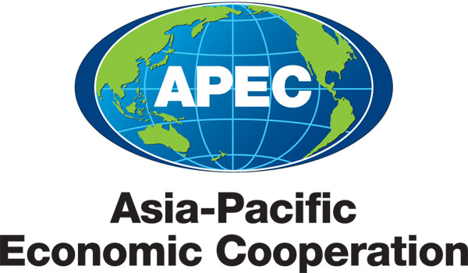

__________________________________________________________________________________

**2011/SOM3/SCSC/SEM/027**

**APEC Wine Regulatory Forum Compendium**

Submitted by: United States

|  |  |
| --- | --- |
|  | Seminar on Key Issues in Wine RegulationSan Francisco, United States18–19 September 2011 |

**Compendium of APEC Economies’ Certificate Requirements for Wine Importation**

The purpose of the compendium is to provide a starting point for discussions at the APEC Wine Regulatory’ Forum on September 18-19, 2011, on certificate requirements for wine importation.

The Compendium provides information on the diversity of requirements, with a vision of eliminating or minimizing the number of different certificates that need to be issued in order to export wine into APEC economies.

The information was collected through the WTO SPS/TBT contact points and supplemented by the U.S. Department of Agriculture Foreign Agricultures Service.

**Diagram of the Compendium**

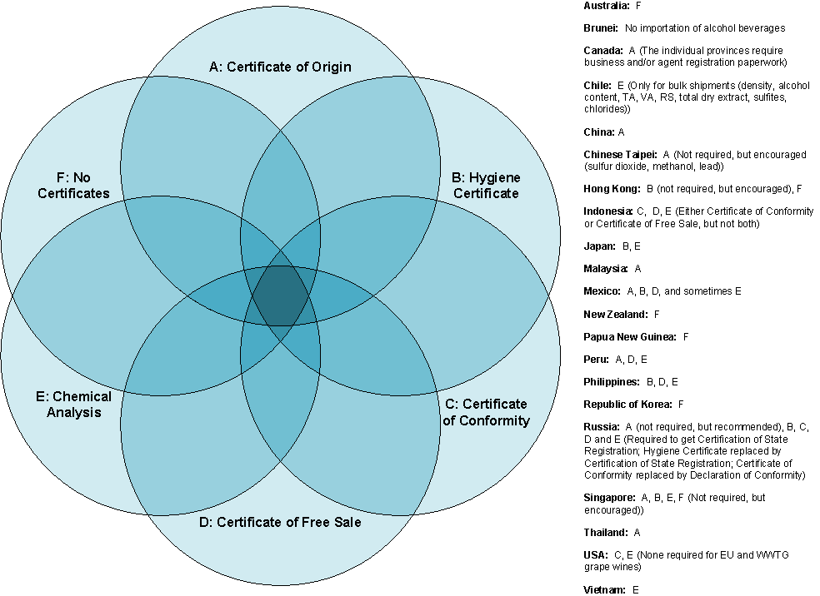

**Chart of the Compendium**

|  |  |  |  |  |  |  |
| --- | --- | --- | --- | --- | --- | --- |
| **Economy** | **Cert. of Origin** | **Hygiene Cert.** | **Cert. of Conformity** | **Cert. of Free Sale** | **Chemical Analysis** | **No Certs.** |
| Australia |  |  |  |  |  | x |
| Brunei |  |  |  |  |  |  |
| Canada |  |  |  |  |  |  |
| Chile |  |  |  |  | x |  |
| China | x |  |  |  |  |  |
| Chinese Taipei |  |  |  |  |  |  |
| Hong Kong, China |  | x |  |  |  | x |
| Indonesia |  |  | x | x | x |  |
| Japan |  | x |  |  | x |  |
| Malaysia | x |  |  |  |  |  |
| Mexico | x | x |  | x | sometimes req. |  |
| New Zealand |  |  |  |  |  | x |
| Papua New Guinea |  |  |  |  |  | x |
| Peru | x |  |  | x | x |  |
| Philippines |  | x |  | x | x |  |
| Republic of Korea |  |  |  |  |  | x |
| Russia | x | x | x | x | x |  |
| Singapore | x | x |  |  | x | x |
| Chinese Taipei | x |  |  |  |  |  |
| Thailand | x |  |  |  |  |  |
| USA |  |  | x |  | x |  |
| Vietnam |  |  |  |  | x |  |