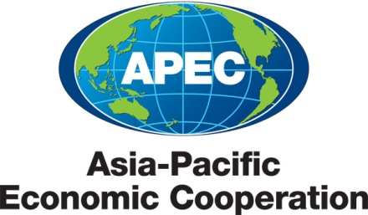

__________________________________________________________________________________

**2011/SOM3/SCSC/055**

Agenda Item: 4(8)

**APEC Wine Regulatory Forum Report**

Purpose: Information

Submitted by: United States

|  |  |
| --- | --- |
|  | **Second Sub-Committee on Standards and Conformance Meeting**  **San Francisco, United States**  **20-21 September 2011** |

**APEC Subcommittee on Standards and Conformance**

**APEC Wine Regulatory Forum Report**

**Background**

At the SOM I meeting held in Lima, Peru in 2008, the APEC Sub-Committee on Standards and Conformance (SCSC) endorsed the establishment of a Wine Regulatory Forum (WRF)[1]. This report summarizes the discussions and outcomes of the APEC Wine Regulatory Forum Seminar held in San Francisco, California on September 18-19, 2011[2].

The WRF Seminar marked the first-ever meeting of wine regulators and industry from both wine producing and consuming economies. The seminar was sponsored by the United States, and cosponsored by Australia, Chile, New Zealand, and Peru. Eighteen of the 21 member economies participated and twelve served as speakers[3]. The event included a facilitator-led Regulators Breakfast, and tours of the Concannon Vineyard Winery in Livermore Valley and the U.S. Alcohol and Tobacco Tax and Trade Bureau’s Compliance Laboratory in Walnut Creek, California. The WRF seminar produced two reference documents: “The Compendium of Wine Import Certificate Requirements of APEC Economies” and the “APEC Wine Regulatory Forum Contact List”.

**Overview of APEC Wine Trade** [4]

APEC region trade in rice, grape and other fruit wine has grown dramatically in importance for both exporting and importing economies.



As wine consumption increased, trade in wine among APEC economies and other world nations increased tremendously. In 2010, the value of the APEC economies’ global wine trade climbed to US $18 billion.



Over the past decade, there has been an enormous growth in wine exports from Asian APEC economies. The value of these exports climbed nearly fourfold to approximately US$ 665 million, with high rates of growth to APEC economies in both the Americas and Oceania.



There have also been increases in the value of wine exports from APEC economies in the Americas and in Oceania. In total, the value of wine trade among APEC economies soared from US$ 1.1 billion in 2000 to US$ 3.6 billion in 2010, an increase of 223%.



**Targeted Outcomes of CTI: SCSC 40/2010T (as envisioned in the project proposal)**

The WRF met the project goals as listed in the project proposal. Participants have:

* Identified key principles for regulations that could be considered when regulating rice, grape and other fruit wine with a view to promoting regulatory alignment in the region and removing costly, unnecessary and unduly burdensome regulatory choke points with respect to oenological practices, definition and/or description of products and labeling requirements and methods for analyzing, assessing, or certifying wine products;

* Gained better knowledge and understanding of recommendations issued by relevant International fora, including inter alia, the Codex Alimentarius Commission, World Trade Organization (WTO), International Organization of Wine and the Vine (OIV), and the World Wine Trade Group (WWTG) and will be able to apply these when implementing new laws or regulations; and
* Established stronger linkages with government departments of other APEC economies and relevant non-government entities (such as laboratories) to enable regular consultation and timely exchange of information. This will assist with the prompt resolution of questions and disputes concerning labeling, Maximum Residue Limits (MRLs), compositional or certification requirements, counterfeiting and smuggling of wine products, geographical indications and food safety and health concerns.

**Seminar Outcomes and Next Steps**

Participants wish to suggest the following principles and next steps. Economies, in coordination with industry and other stakeholders, should seek to:

**Build on established networks:** Economies should build on established networks and processes, particularly to strengthen their abilities to share information in international bodies, including the Codex Alimentarius Commission and the World Wine Trade Group. Economy regulators should also use the *APEC Wine Regulatory Forum Contact List* (2011/SOM3/SCSC/ XXX) to enable regular consultation and timely exchange of information among members.

**Reduce barriers to wine trade:** Economies should review and compare the policies outlined in the *Compendium of Certification Requirements* (2011/SOM3/SCSC/ XXX), with an eye towards eliminating unnecessary barriers to trade. Economies should also consider participating in the work of the Food Safety Cooperation Forum and refer to the CODEX guidance on export certificates when deciding on what to incorporate into required documentation. Economies are encouraged to participate in the November APEC Export Certificate Workshop in DC.

**Develop a forward-looking work plan:**

Economies should use a broad range of economy, industry, and academic stakeholders to build upon the ideas discussed in this Seminar. Interested parties should meet to discuss mutual priorities, including:

* Increasing information exchange on regulatory developments and labeling issues in order to increase confidence among economies
* Eliminating or reducing the need for export certificates, possibly by achieving mutual acceptance of oenological practices under appropriate conditions
* Accepting an electronic means for the submission of export certificates or by consolidating the information on various certifications into one
* Identifying opportunities to reconvene at a future date to continue the dialogue on the issues raised at the Seminar including to identify capacity building needs and activities.

**Summary of the Wine Regulatory Forum Seminar[5]**

Ms. Julia Doherty, Chair of the APEC Sub-Committee on Standards and Conformance (USA) opened the event by welcoming participants to the third SOM of the U.S. host year. Mr. Robert P. Koch, President and Chief Executive Officer of the Wine Institute, gave the private sector welcome and stated that the Wine Institute is fully committed to the APEC goals to reduce trade barriers and expand trade. Mr. James Finkle, President, of FIVS; and representing Constellation Brands, Inc, introduced the Honorable Michael Moore, New Zealand Ambassador to the United States.

**Keynote Address:Honorable Michael Moore, New Zealand Ambassador to the United States:** The Honorable Michael Moore is New Zealand’s Ambassador to the United States, a past Director-General of the World Trade Organization (WTO), and former Labour Prime Minister of New Zealand. He made several key points in his remarks about the work being undertaken by the WRF. He noted that regional trade in wine is quickly growing in significance, but it is burdened by major costs due to different and sometimes conflicting regulatory requirements.  Estimates suggest that the cost to APEC economies and businesses is approximately $1 billion USD per year. New Zealand’s experience suggests that an open market and a streamlined regulatory environment is a necessary pre-condition for the development of domestic wine production and trade. APEC has an important role to play in promoting processes that support regulatory coherence to address real business concerns and shape practical solutions.

**APEC Wine Trade and Regulatory Coherence Panel**. Moderator: Ms. Sirma Karapeeva, New Zealand Ministry of Economic Development

* *Mr. Tony Battaglene, General Manager, Strategy & International Affairs, Winemakers Federation of Australia*

Wine production and trade are influenced by a large number of external organizations and agreements that impact on domestic policy and regulation. National standards, international trade agreements, bilateral wine trade agreements, and government regulation can impose huge burdens on wine producers. Economies should consider five principles of better regulation when crafting new wine regulations. New measures should be proportionate, accountable, consistent, transparent, and targeted. Regulations should not be made in isolation; good regulatory practice requires collaboration between regulators and industry.

* *Dr. John Barker, General Counsel, New Zealand Winegrowers*

The World Wine Trade Group (WWTG) provides an example of regulatory coherence in practice. The WWTG has established a highly effective process to address non-tariff trade barriers and model regulatory best practice between key wine producing and consuming countries. Relationship-building around shared objectives, a flexible structure, stakeholder involvement, and a facilitative approach have been the key elements in the success of the WWTG. This is an approach that may have wider applicability for APEC. APEC economies are encouraged to participate in the WWTG as observers.

* *Ms. Gail Davis, Director, U.S. Alcohol and Tobacco Tax and Trade Bureau (TTB) International Trade Division*

The APEC Compendium of Certification Requirements for Imported Wine in APEC Economies outlines the five different types of certification requirements used in APEC. The current certification requirements are diverse and difficult to understand, especially given the lack of common definitions. TTB issued 2,500 certificates in 2010, fifty percent of which went to China. Seventy-seven percent of all certificates are issued to APEC economies. Regulators need tools to help ensure the safety of wine imported into their economies, however, the current use of multiple certifications in APEC causes barriers to trade in wine. Regulators should review their use of multiple certificates and consider streamlining the process.

Diagram of the Certification Requirements in APEC

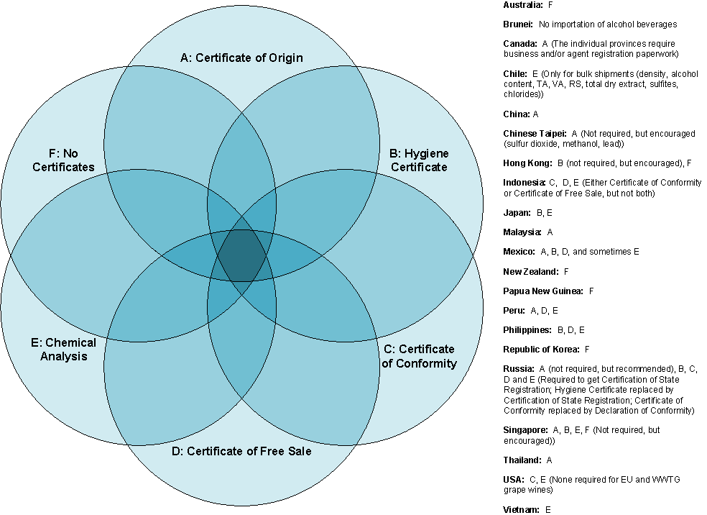

**Economy Presentations Panel. Moderator:** Ms. Gail Davis, Director, U.S. Alcohol and Tobacco Tax and Trade Bureau (TTB) International Trade Division

APEC economy presentations touched on certification, oenological practices, approved additives, processing aids, and labeling of wine. Detailed information about the organizations that oversee wine regulation, domestic production and consumption were outlined. Among most economies, the most common problem in wine importation was improper labeling among. Export certificate requirements were discussed.

Economies were represented by the following officials:

* *Chile: Mr. Joaquín Almarza Agriculture and Livestock Service*
* *China: Mr. Han Yi, Deputy Director, Division of Industrial Food, Import and Export Food Safety Bureau, AQSIQ*
* *Japan: Dr. Nami Goto-Yamamoto, Director, Fundamental Research Division, National Research Institute of Brewing*
* *Korea: Mr. Jongsoo Kim, Deputy Director, Liquor Safety Management Taskforce, Food Safety Bureau, Korea Food & Drug Administration*
* *Mrs. Alejandra Vargas Arrache, Director for International Trade Rules, Ministry of the Economy Peru:*
* *Peru: Mr. Alfredo San Martin, President, Peru Technical Standardization Committee on Alcoholic Wine Beverages*
* *Chinese Taipei: Mr. Minghui Tang, Deputy Director-General, National Treasury Agency, Ministry of Finance*
* *Thailand: Ms. Prem Malhorta, Director, International Affairs Bureau, Thai Industrial Standards Institute*

**The Importance of International Organizations and Standards.** Moderator: Mr. James B. Clawson, President, JBC International

* *Mr. Tony Battaglene, General Manager, Strategy & International Affairs, Winemakers Federation of Australia*

The international organizations that affect the wine industry include the: World Trade Organization (WTO), World Wine Trade Group (WWTG); International Organisation of Vine and Wine (OIV), CODEX Alimentarius (CODEX), International Organization of Legal Metrology (OIML), FIVS the worldwide federation for beer, wine, and spirits, World Health Organization (WHO). Many APEC economies also participate in regional and bilateral free trade agreements where negotiations occur on wine issues.

* *Dr. Dennis Keefe, Office of Food Additive Safety, U.S. Food and Drug Administration*

The standards adopted by Codex Alimentarius are the benchmark for food safety under the World Trade Organization, and under its classification wine is included as food. The central role and development of the Codex General Standard Food Additives was outlined and economies were encouraged to participate in the elaboration of the Codex standard.

* *Ms. Lori Tortora, International Trade Specialist, Processed Products & Technical Regulations Div., USDA Foreign Agricultural Service/OASA*

The Codex Alimentarius Commission undertook the development of guidance documents on food import and export inspection and certification systems in 1991. The Codex Committee on Food Import and Export Inspection and Certification Systems (CCFICS) provides guidance on the need for and appropriate use of export certificates. APEC wine regulators were encouraged to use a standard format for certification requirements and to refer to the basic APEC model for guidance.

* *Ms. Julia Doherty, Chair, APEC Sub-Committee on Standards and Conformance*

The WTO Technical Barriers to Trade and Sanity and Phytosanitary (SPS) provisions were introduced. The role of these provisions in helping economies to reduce costs and

delays attributable to unnecessary, duplicative, and unclear testing regimes was discussed. Economies were encouraged to use APEC to resolve bilateral trading issues in order to avoid elevating issues to the WTO TBT. Wine issues currently discussed in the WTO TBT Committee were reviewed.

**Best Practices in Wine Regulation Panel. Moderator:** Mr. Wade Armstrong, Principal Adviser Trade Policy, New Zealand Ministry of Foreign Affairs & Trade

* *Mr. Robert Kalik, World Wine Trade Group*

The two WWTG[6] international treaties were detailed: the Mutual Acceptance Agreement on Oenological Practices (MAA)[7], and the Agreement on the Requirements for Wine Labeling[8]. Signatory economies to the MAA accept the winemaking regulations and practices of the exporting economy, thus eliminating the need for testing of imported wines; however, health and safety issues remain in the purview of the economy. Signatory economies to the Labeling Agreement agree to the placement of four items country of origin, product name, net contents, and alcohol content in a single field of vision. Importing authorities are allowed to require additional labeling information. The agreement was signed by all WWTG members on January 23, 2007 in Australia. APEC economies can participate in the WWTG as observers.

* *Mr. Federico Mekis, International Legal Advisor, Wines of Chile*

The use of pesticides and their regulation in wine were discussed. Economies should note that the SCSC Initiative in the Food Safety Cooperation Forum has undertaken work in the area of MRLs in an effort to facilitate trade and protect public health.

* *Mr. Dan Paszkowski, President and Chief Executive Officer, Canadian Vintners Association*

Bilateral trade agreements were reviewed with a focus on the Canadian wine experience through the Canada-US Free Trade Agreement and the Canada-EU Wine and Spirits Agreement.  The benefits of bilateral trade agreements and how they support best regulatory practices, collaboration and a harmonized environment for free trade in wine were outlined.

**Regulator-to-Regulator Session: Sharing of Current Practices and Recent Developments.** Opening Statement byMr. William Foster, Assistant Administrator, Headquarters Operations, TTB. Session Facilitated by Dr. Gina L. Myers

The key themes from day one of the APEC WRF were reviewed:

* conformity in wine labeling
* need for better regulations at lower costs
* balance between commercial vs. government requirements
* need for intergovernmental organizations to cooperate
* sharing of economy points of contact for the wine sector
* use of Codex standards for a model of certifications
* trust needed to move away from certifications towards mutual recognition
* sharing of technical assistance
* use of electronic certificates
* need for a clear understanding of why multiple certificates are needed

Regulators were asked to identify the number one issue concerning the regulation of wine in their economy:

* outdated wine regulations that need to be reviewed and updated.
* inadequate staff dedicated to food and wine regulations.
* inability to offer documents in English
* lack of confidence that exporting economies’ controls are secure
* need to move away from a model of 100% inspection to a risk-managed approach
* developing countries lack lab capacity and are reliant on exporting economies’ controls
* need for assistance in addressing public health concerns regarding the abuse of wine and other alcoholic beverages
* need to ensure that imported and exported products comply with applicable requirements

Regulators were asked what they need to address the key regulatory issues in their economies:

* increased information sharing among economies
* capacity building for risk management systems and support in developing new regulations
* increased participation in the OIV and WWTG in consultation with industry
* guidance on how to test for pesticides in wine
* movement toward standardization of wine testing among economies

Regulators suggested the following next steps:

* continue the dialogue either through electronic meetings or in person
* matrix of analytical methodologies be compiled
* matrix of labeling and enological practices be compiled

**The Role of Laboratory Testing in Wine Regulation and Trade Panel**. Moderator: Dr. Greg Hodson, Chief Technical Regulatory Liaison, E&J Gallo Winery

* *Mr. Warren Stone, Director of Science Policy, Compliance & Inspection, Grocery Manufacturers Association*

The efficacy of product testing effectiveness as both a control and verification tool was discussed. Statistical realities surrounding product testing and examples of protocols and general approaches that serve to make testing plans effective, useful and flexible were detailed. Testing, in itself, is not a control measure. Economies were discouraged from using testing as a measure to control product safety.

* *Dr. Abdul Mabud, Director Scientific Services Division, TTB*

The role of the U.S. Alcohol and Tobacco Tax and Trade Bureau (TTB) and its dual missions to collect all revenue on alcohol and tobacco products, and protect the public by preventing consumer deception, ensuring compliance of federal commodity, safety and distribution laws was outlined. Major TTB programs were discussed including the Alcohol Beverage Sampling Program, the Pesticide Monitoring Program and the Product Integrity Program. TTB operates four state of the art labs in the United States: three in Maryland and one in Walnut Creek, Ca.

* *Mr. Gordon Burns, ETS Laboratories*

Laboratory accreditation provides a flexible alternative to legislation, facilitates world trade, and can be used as an efficient monitoring tool for governments and regulators.   
For businesses, accreditation provides greater acceptance of products opening up market access, minimizes product failures and recalls, and avoids costs associated with multiple testing. Consumers can also benefit from products tested in accredited labs through increased public confidence in product quality. Accreditation provides assurance that laboratory results are: accurate, traceable, reproducible, uniform, and defensible.

* *Dr. George Soleas, Senior VP, Logistics and Quality Assurance, Liquor Control Board of Ontario*

An overview of the testing and certification of alcoholic beverages by the Liquor Control Board of Canada was discussed. Products are organoleptically evaluated, chemically tested and certified by the LCBO’s ISO-accredited Quality Assurance Department. Approximately 500,000 individual tests are performed on more than 23,000 products annually.

* *Mr. Steve Guy, General Manager, Compliance and Trade, Wine Australia*

The laws and systems that Australia has adopted in order to ensure the quality of Australian wine was outlined. It emphasizes the benefits of assuring quality at the source, rather than through inspection at the destination, and advocates that, in those cases where analytical testing proves necessary, test reports from facilities accredited to international standards provide the highest degree of confidence. It was noted that most micro-organisms and all pathogenic micro-organisms cannot live in wine due to the ethanol content, making wine a relatively low risk consumer product.

**Regulator Tour of the TTB Compliance Laboratory**

Approximately 40 APEC wine regulators visited the TTB Compliance Laboratory in Walnut Creek on September 19, 2011.  The Compliance Laboratory provides support to TTB through product integrity testing and by monitoring regulatory compliance of both beverage and non-beverage alcohol products.  
  
TTB provided an overview of the role the Compliance Laboratory plays in regulating wine, including compliance monitoring of beverage and non-beverage products submitted as the result of product integrity inspections, the Alcohol Beverage Sampling Program to check products in the retail market for regulatory compliance, sulfur dioxide waiver requests for wines, special testing for the evaluation of new wine making processes, mycotoxin contamination in wine and malt beverages, and on-site technical assistance to the regulated industries and to TTB investigators.  
  
Regulators from the APEC economies participated in a question-and-answer session with TTB chemists on their work in regulating the US wine market.

**Acknowledgements**

Special thanks to Tom LaFaille (Wine Institute), Julia Doherty (USTR), Gail Davis, (TTB), Mari Kirrane (TTB), Jennifer Stradtman (USDOC/ITA), and Jamie Ferman (USDOC/ITA) for their significant contributions to this project.

1. 2008/SOM3/SCSC/003
2. Presentations from the APEC Wine Regulatory Forum are posted on the APEC Meeting Document Database and the Wine Institute website: http://www.wineinstitute.org/APEC
3. In agenda order: United States, New Zealand, Australia, Chile, China, Japan, Korea, Mexico, Peru, Chinese Taipei, Thailand, and Canada.
4. Wine data was taken from Mr. Jon A. FREDRIKSON’s presentation “Overview of APEC Wine Trade”.
5. Key points from each presentation are summarized here. For more information, refer to the complete presentations available on the APEC Document Database website and the Wine Institute website at: http://www.wineinstitute.org/APEC
6. WWTG members are USA, Argentina, Australia, Chile, Canada, Georgia, New Zealand and South Africa
7. The MAA was signed in 2001; all 8 are signators.
8. The Labeling Agreement went into force in 2010; all 6 of 8 are signators.